Unit 3: Matter and Energy in Living Systems

Digestion, Circulation, and Healthy Living
Our bodies have many systems that work together to keep us healthy. The digestive and circulatory systems are key to making sure our cells get both nutrients and oxygen to function properly and keep us alive.

The Digestive System: Taking in Matter
- The digestive system is how your body takes in food and breaks it into tiny molecules your cells can actually use.
- Food is mechanically broken down (chewing, churning in the stomach) and chemically broken down (enzymes and stomach acid).
- By the time food reaches the small intestine, nutrients (like glucose, amino acids, vitamins, minerals, and fatty acids) are absorbed into the bloodstream.
- This absorption increases the blood sugar level (energy available to cells) and mineral levels (e.g., calcium, sodium).
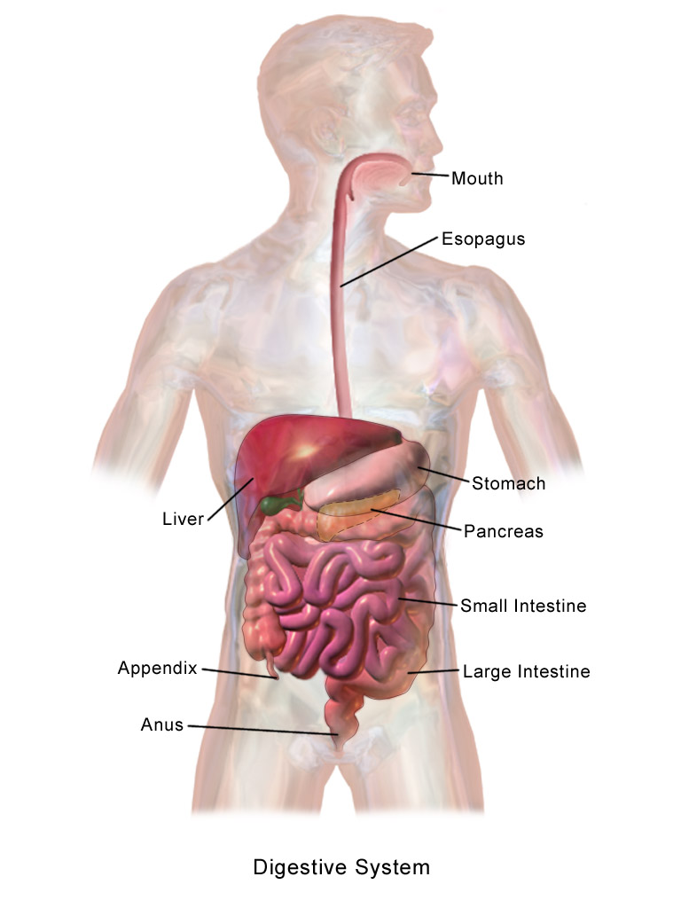
BruceBlaus, CC BY-SA 4.0 <https://creativecommons.org/licenses/by-sa/4.0>, via Wikimedia Commons
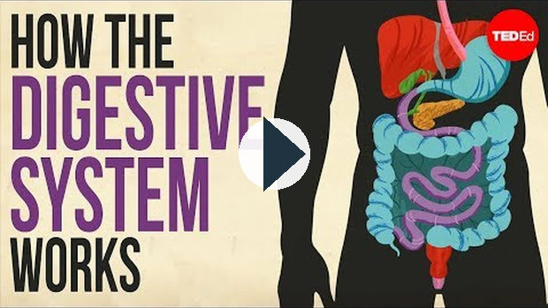
https://www.youtube.com/watch?v=Og5xAdC8EUI

The Circulatory System: Transporting Matter
Once the digestive system has brokend down and released nutrients into the blood, the circulatory system takes over and transports the materials to the rest of the body.
- The heart pumps blood, moving nutrients, oxygen, and hormones around the body.
- The lungs add oxygen to the blood and remove carbon dioxide.
- Together, the heart + lungs + blood vessels make sure the nutrients from digestion reach every single cell, while wastes are carried away.
Circulatory System
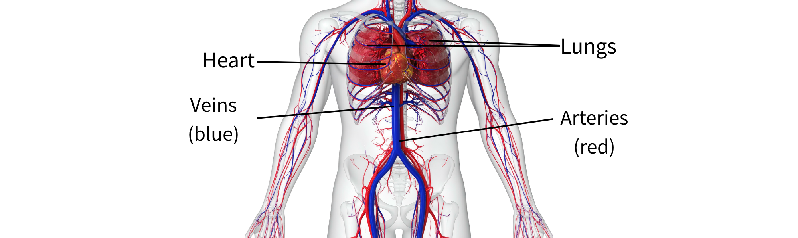

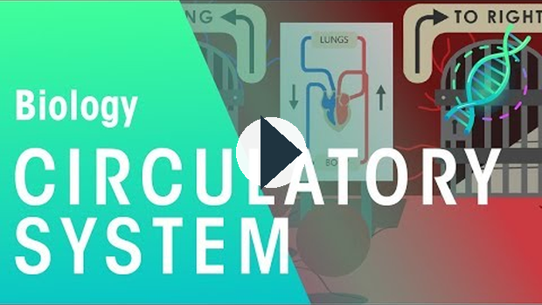
https://www.youtube.com/watch?v=73ei6YD0VnM

Digestive + Circulatory Systems Working Together
Here are 4 steps showing us how food entering the body eventually makes it to our cells. The digestive and circulatory systems working together is key to our body functioning properly.
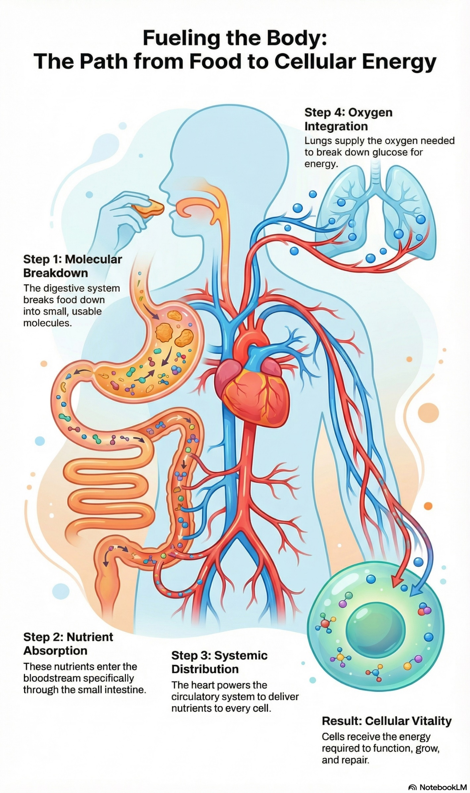
Step 1: Digestive system breaks food into small molecules.
Step 2: Nutrients enter the bloodstream in the small intestine.
Step 3: The circulatory system, powered by the heart, delivers nutrients to every cell.
Step 4: The lungs supply oxygen needed for cellular respiration (breaking down glucose for energy).
Result: Cells get energy and nutrients to function, grow, and repair.

Why Healthy Eating Matters
A variety of nutrients is necessary to keep your body healthy and perform its many functions. A balanced diet gives your body the raw materials it needs for:
- Energy (carbohydrates, fats)
- Growth & repair (proteins)
- Regulation of body functions (vitamins, minerals, water)
Canada’s Food Guide recommends eating:
- Plenty of vegetables and fruits 🌱🍎
- Whole grain foods 🍞
- Protein foods 🥩 🫘 🐟 (animal or plant-based)
- Limited amounts of foods high in sugar, salt, or saturated fats.

https://www.youtube.com/watch?v=85Cm78MsOkE
Key Takeaway:
Your digestive system breaks food down into nutrients. Your circulatory system moves those nutrients (and oxygen) to your cells. A healthy diet keeps this partnership running smoothly. Too much salt, sugar, or fat stresses the system, while balanced diets (including vegetarian ones) keep you strong and healthy.

Digestion, Circulation, and Healthy Living Continued......
Now that you have learned how the body takes in and distributes nutrients using its systems, it's time explore nutrition.

Investigating Nutritional Needs
- Food labels show serving size, calories, fat, sodium, protein, carbohydrates, and vitamins.
- By reading labels, you can:
- Compare two brands of the same food (e.g., yogurt with 0% fat vs. yogurt with added sugar).
- Spot foods that are “nutrient-dense” vs. “empty calories.”
- Popular diets (e.g., low-carb, high-protein, vegan, keto) can be evaluated by checking if they meet the body’s full nutrient requirements.
The Canadian Food Guide website summarizes how to understand a nutrition label in three simple steps. You can find this label
on the back of all food products. For more information visit: Healthier Choices with the Canada Food Guide
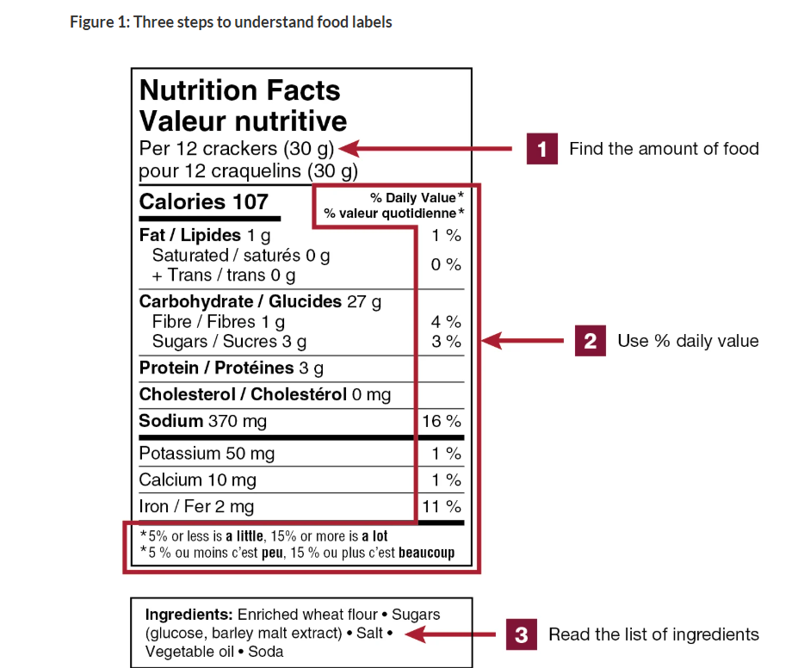

The Problem with Too Much of a Good Thing
When we consume too much of certain nutrients contained in food, it can cause health issues. Your body needs fat and salt, but moderation is key.
Nutrient | Effects of Consuming Too Much
cholesterol | clogs arteries, can cause heart disease
salt (sodium) | raises blood pressure, stresses the heart and kidneys
fat | weight gain, increased risk of diabetes and heart disease
Check out this video to learn about the main nutrients from food and how they effect our body.
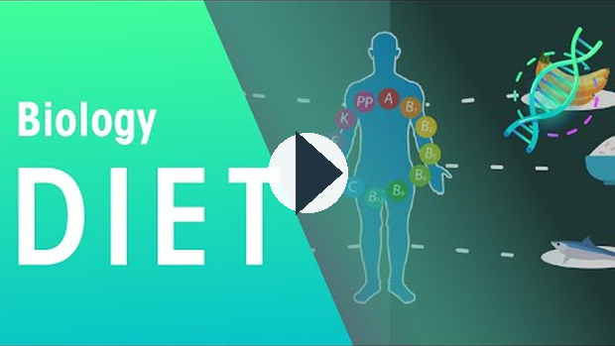
https://www.youtube.com/watch?v=NqV1Ig4_nfI

Mixed and Vegetarian Diets
- Mixed diets (animal + plant foods) usually provide all nutrients easily.
- Vegetarian diets can still be healthy but need planning to include enough protein, iron, vitamin B12, and calcium.
- Plant-based proteins: beans, lentils, tofu, nuts, seeds.
- Many people choose vegetarian diets for health, environmental, or cultural reasons.
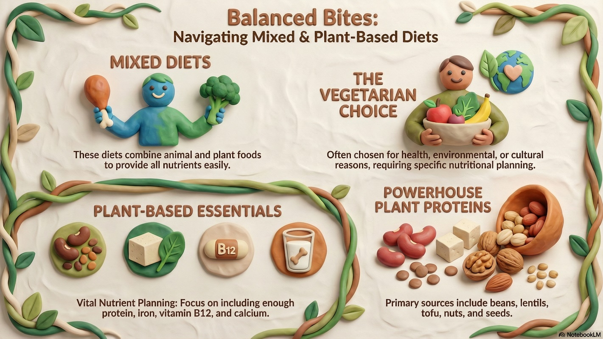

Cultural Impacts on Diet
Understanding and respecting traditional foods is important for health and cultural identity.
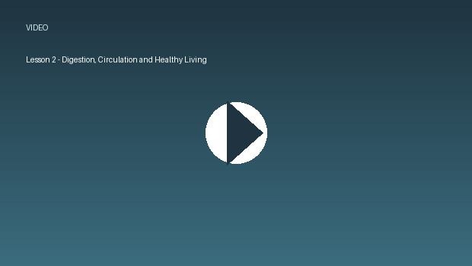
../02_SUPPORTING_FILES_BY_UNIT/Linked Media/Lesson 2 - Digestion, Circulat-f5f10416bd.mp4
- Traditional Indigenous diets in Alberta included wild game, berries, roots, fish, and other natural foods.
- Modern processed foods (high in sugar, fat, and salt) have replaced many traditional foods.
- This shift has led to rising health problems in many communities, such as diabetes, high blood pressure, and heart disease.

Disorders of the Digestive & Circulatory Systems

Maintaining Balance (Homeostasis)
Homeostasis = the body’s way of keeping everything in balance (like temperature, blood sugar, blood pressure, pH).
The digestive system supplies nutrients → circulatory system distributes them.

  - Stable blood sugar levels (so your brain and muscles work). Together, they maintain:
  - Balanced water and mineral levels.
  - Proper oxygen + nutrient delivery to all cells.
If one system fails, the other is affected → the balance is disrupted.
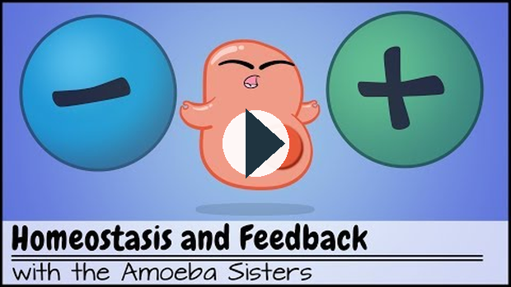
https://www.youtube.com/watch?v=Iz0Q9nTZCw4
Launch the activity on homeostasis to practice your understanding. Make sure to try the CHALLENGE ME questions.
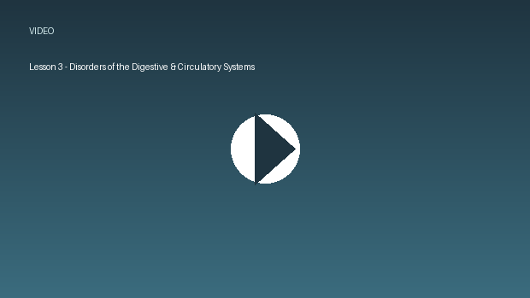
https://www.ck12.org/assessment/tools/geometry-tool/fullscreen.html?qID=55cbae438e0e081fcfd54658&aid=2172026&cch=biology-::-homeostasis&eId=SCI.BIO.908&cci=3

What Happens When Balance Fails?
When the body can’t adjust to big disturbances, illness or even death can occur. Examples:

  - Appendicitis – infection/inflammation of the appendix. If untreated, it can rupture.
  - Kidney failure – wastes build up in the blood if kidneys can’t filter.
  - Heart attacks – blood flow to the heart muscle is blocked, damaging the heart.
These problems show how digestive, excretory, and circulatory systems are linked.
Causes of Disorders

a) Genetic Factors (inherited)

  - Some people are born with conditions that affect their systems.
  - Examples:
1) Cystic fibrosis – affects digestion and nutrient absorption.
2) Familial high cholesterol – leads to early heart disease.
3) Crohn’s disease – a genetic digestive disorder causing inflammation.

b) Lifestyle Factors (choices)

  - Some people make choices in their daily lives that lead to unhealthy systems
  - Examples:
1) Diet: too much fat, sugar, or salt → obesity, diabetes, high blood pressure, heart disease.
2) Exercise: lack of physical activity → weak circulation, clogged arteries.
3) Substance use: smoking damages arteries; alcohol affects the liver and digestion.

c) Environmental Factors (surrounding environment)

  - Some people have living conditions that are hard on the body
  - Examples:
1) Pollutants or chemicals can damage organs.
2) Contaminated water or food can cause digestive infections (e.g., E. coli, parasites).
2) Stress can contribute to ulcers and heart problems.

Technology that Helps Us
Science and technology play a big role in diagnosing and treating imbalances:

  - Endoscope – tiny camera inserted into the digestive tract to check for ulcers, bleeding, or cancer.
  - Stethoscope – lets doctors hear heartbeats and blood flow in arteries.
  - Kidney dialysis machine – acts like an artificial kidney, filtering waste from the blood.
  - Pacemaker – sends electrical impulses to keep the heart beating at the right rhythm.
  - Blood pressure monitors & ECG machines – track circulation health.

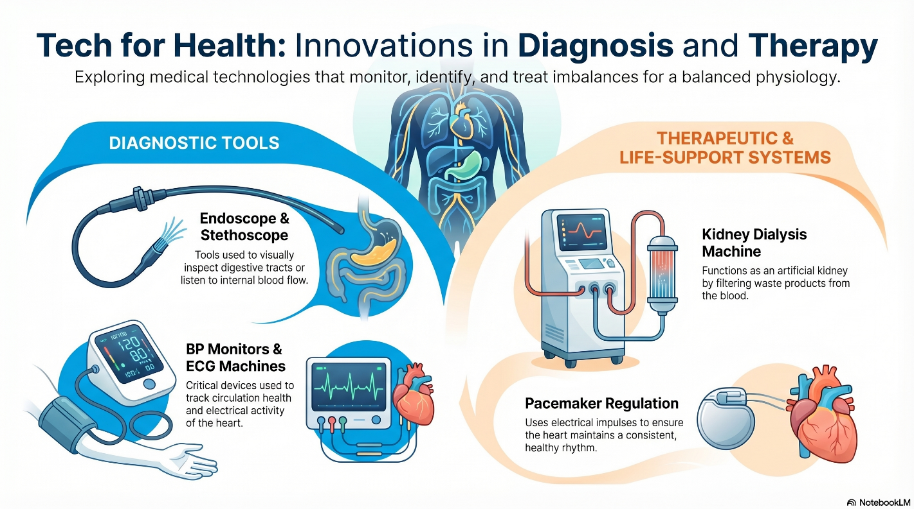

Social Factors Affecting Health
Your environment, culture, and society also affect digestive and circulatory health:

  - Stress & lifestyle → ulcers, high blood pressure.
  - Body image pressures → eating disorders like anorexia (starving to lose weight) and bulimia (binging then purging).
  - Diet trends → high-fat fast foods vs. balanced traditional diets.
  - Lack of fitness → increases risk of obesity, diabetes, and heart disease.
  - Cultural shifts – Indigenous and other cultural groups moving away from traditional foods toward processed ones face higher rates of digestive and circulatory diseases.

Plant and Animal Cells – Structure and Function
All living things are made of cells – the smallest unit of life.
Think of a cell as a tiny factory: each part has a job to keep the whole system working.
Just HOW SMALL is a cell? Use the link below to view a comparison between the sizes of different cells and some small objects in the world around us. Move the slider under the image to move through smaller and smaller objects.
Link: Cell Size and Scale
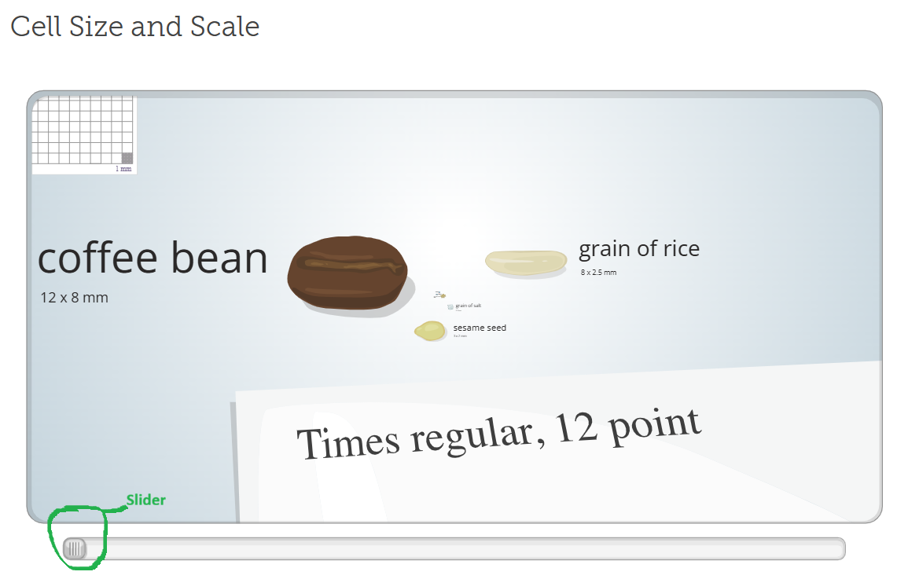

Cell Organelles: Structure and Function
A cell has many important organelles to function properly and maintain homeostasis. Each organelle has a specific job to do. Plant and animal cells have many of the same organelles, but here are several key differences between the two cell types. Watch the video below, examine the diagram and then read through the table.

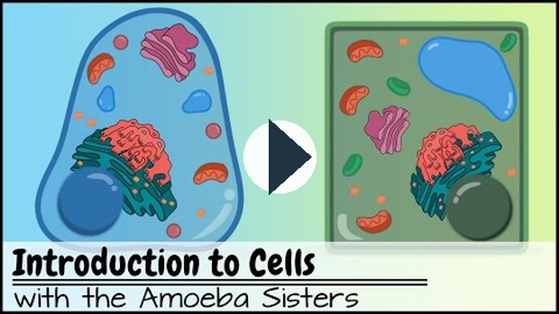
https://www.youtube.com/watch?v=8IlzKri08kk

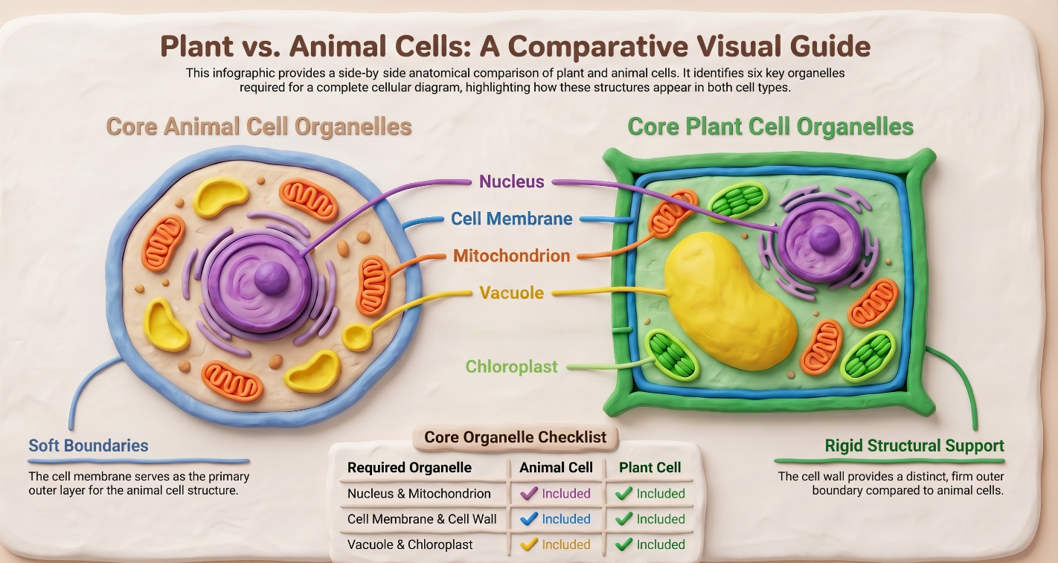

Organelle Name | Found In | Structure | Function
Cell Membrane | Both | Thin, flexible layer that surrounds the cell. | Security Gate: Controls what enters (food, oxygen) and leaves (waste). Keeps the cell stable.
Nucleus | Both | Large, round structure, usually in the center. | Control Center: Contains DNA. Directs all activities like growth, repair, and reproduction.
Vacuole | Both | Fluid-filled sac. Large in plants; small and numerous in animals. | Storage: Holds water, food, and waste. In plants, it provides pressure to keep the plant firm.
Mitochondrion | Both | Small, bean-shaped with folded inner membranes. | Powerhouse: Breaks down glucose and oxygen to create energy ($ATP%bodylt;/span>) for the cell.
Chloroplast | Plants Only | Green organelles containing chlorophyll. | Solar Panels: Captures sunlight for photosynthesis to create glucose (food) and oxygen.
Cell Wall | Plants Only | Tough outer layer made of cellulose, outside the membrane. | Support: Provides strength and protection; helps the plant stand upright.
Use the link below to explore plant and animal cells. Click on each organelle to review its function.
Interactive Plant and Animal Cells: https://www.cellsalive.fun/cellsalive_files/cells/cell_model_js.htm

Quick Comparison
Cell Part | Found in Plants? | Found in Animals? | Function (in simple terms)
Cell membrane | ✅ Yes | ✅ Yes | Controls what enters/exits
Nucleus | ✅ Yes | ✅ Yes | Control center (DNA)
Vacuole | ✅ Large, one | ✅ Small, many | Stores water, food, waste
Mitochondrion | ✅ Yes | ✅ Yes | Produces energy (ATP)
Chloroplast | ✅ Yes | ❌ No | Photosynthesis (makes food)
Cell wall | ✅ Yes | ❌ No | Support + protection

Key Takeaway:
Both plant and animal cells share many of the same “factory parts,” but plant cells have three extras (big vacuole, chloroplasts, and cell wall) that allow them to make their own food and stand tall.

Lesson 5 - Life Functions in Living Systems
All living things, from tiny single cells to entire organ systems, share common life functions. These functions allow organisms to survive, grow, and reproduce.

1. Photosynthesis & Cellular Respiration
Relationship: Photosynthesis stores energy in glucose, while cellular respiration releases that energy for life functions.
Watch the video below to learn about the processes of cellular respiration and photosynthesis: The Energy Cycle of Life

Photosynthesis (plants, algae, some bacteria):
- Captures energy from the Sun.
- Converts it into glucose (sugar), a form of stored chemical energy.
- Word equation: sunlight + water + carbon dioxide → glucose + oxygen.

Cellular Respiration (plants AND animals):
- Releases energy from glucose (using oxygen).
- Provides usable energy (ATP) for cells to function.
- Word equation: glucose + oxygen → energy (ATP) + carbon dioxide + water.

../02_SUPPORTING_FILES_BY_UNIT/Linked Media/Lesson 5 - Life Functions in L-25ac67c15b.mp4

2. Life Functions Common to Living Systems
ALL living things need to carry out the functions below in order to survive.
- Energy conversion – turning food/sunlight into usable energy.
- Response to the environment – reacting to heat, cold, light, sound, etc.
- Growth – adding cells, repairing tissues.
- Reproduction – making offspring.
- Heat regulation (thermal energy):
  - Conservation: fur, feathers, huddling.
  - Dissipation: sweating, panting, vascular skin (blood flow close to surface).
- Special adaptations: Remember that adaptations are behaviors or physical features that organiss develop to survive in their environments.
  - Torpor – short-term reduced activity (like hummingbirds at night).
  - Dormancy – long rest period in plants (seeds in winter).
  - Hibernation – deep sleep during cold.
  - Estivation – deep rest during hot, dry periods (desert animals).
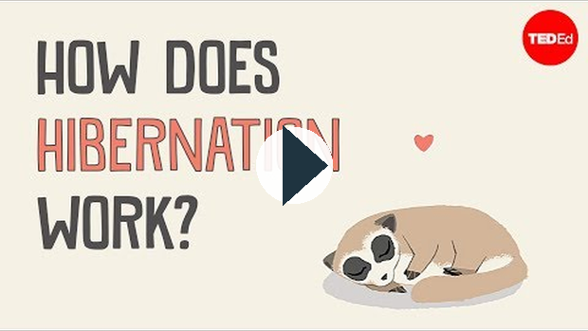
https://www.youtube.com/watch?v=xptpXSTtgSY

3. Organs and Systems in Plants
Just ike animals, plants have their own set of organs and systems to carry out essential life processes for survival.
- Roots – absorb water and nutrients; store food (e.g., sugar beets).
- Stems – support + transport water and nutrients (e.g., sugar cane stores sugar).
- Leaves – photosynthesis (stomata control water balance and gas exchange).
- Flowers/seeds – reproduction.

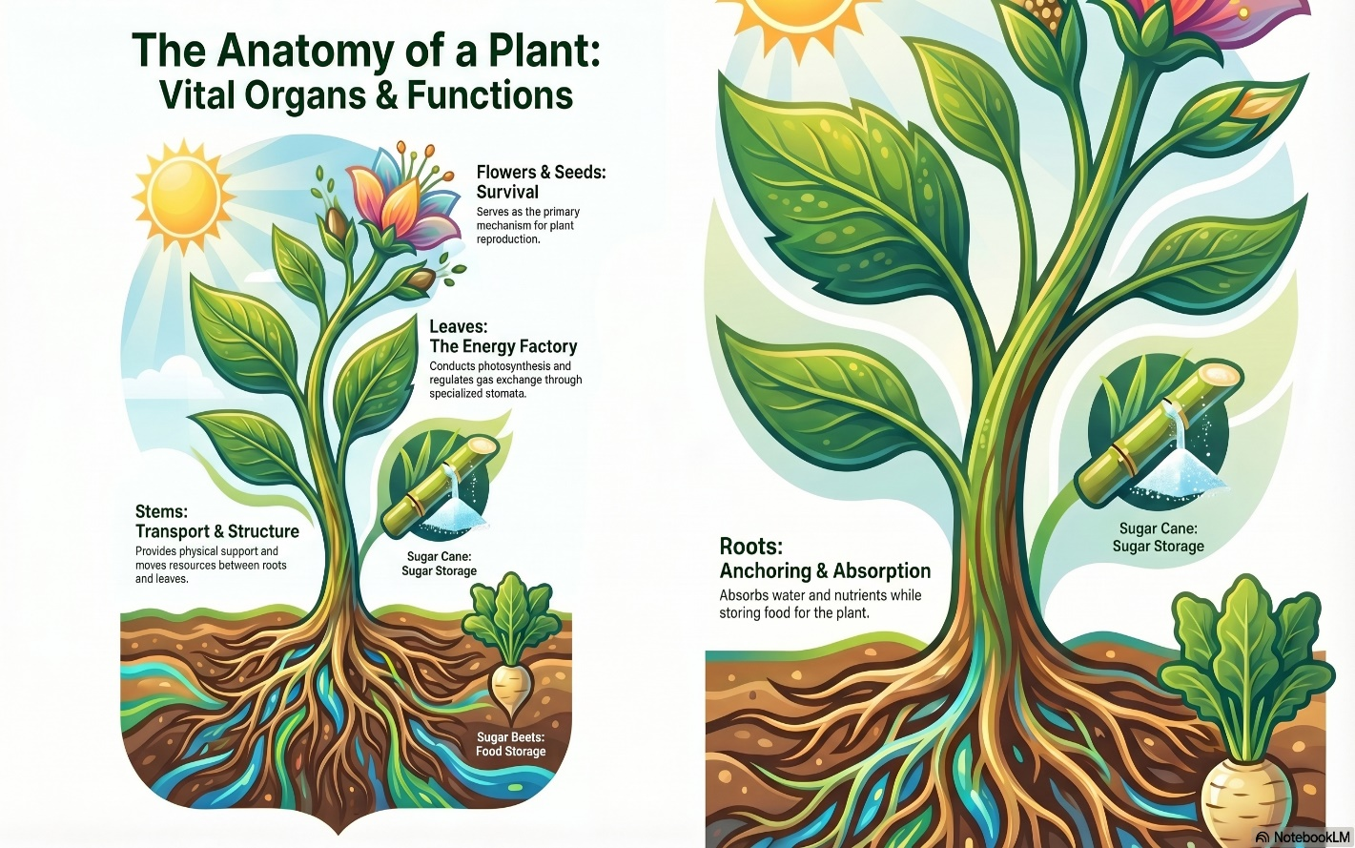

4. Major Human Organ Systems and Their Functions
The human body has many systems that work both independently and with one another in order to carry out the necessary functions keep our bodies healthy.

Major Human Body Systems
Body System | Primary Functions
Digestive | Breaks down food into nutrients that the body can absorb.
Circulatory | Transports nutrients, oxygen, and wastes throughout the body via the blood.
Respiratory | Facilitates gas exchange (taking oxygen in and releasing carbon dioxide out).
Nervous | Detects changes in the environment and coordinates the body's response.
Skeletal & Muscular | Provides structural support and enables physical movement.
Excretory | Removes metabolic wastes from the body (includes kidneys, bladder, and skin).
Reproductive | Responsible for the production of offspring.
Integumentary (Skin) | Provides protection and regulates body temperature (e.g., sweating).
Immune | Acts as the body's defense mechanism against diseases and pathogens.

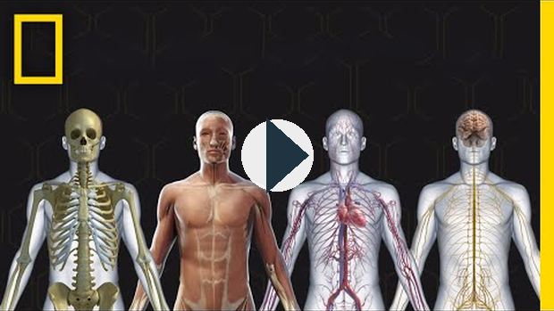
https://www.youtube.com/watch?v=Ae4MadKPJC0

5. Cell Structures Adapted for Life Functions
Both plants and animals have different types of cells to carry out specific jobs. Here are a few examples:
- Stomata (plants) – pores on leaves that open/close to balance water loss and gas exchange.
- Skin cells (animals) – flat and layered to cover a large surface area and protect the body.
- Cell walls (plants) – provide strength and structure so plants can grow tall.
- Nerve cells (neurons) – long and thin, designed to carry electrical signals quickly.
- Storage cells – roots (sugar beets), stems (sugar cane), fruits (apples) store energy.

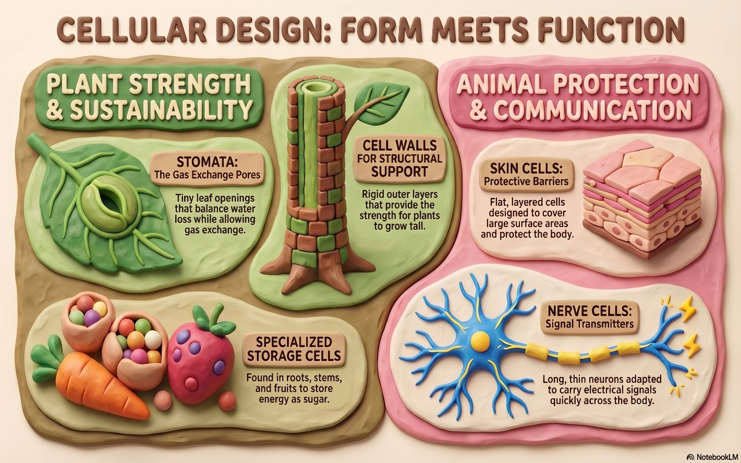

6. Technology to Monitor Human Life Functions
Modern tools help track and protect our health:
- Ultrasound – images inside the body (e.g., pregnancy, organ health).
- Heart monitor (ECG) – tracks heartbeat and rhythm.
- Blood pressure cuff – measures blood pressure.
- Blood glucose monitor – measures blood sugar for people with diabetes.
These tools help doctors diagnose problems and people manage their own health.

../02_SUPPORTING_FILES_BY_UNIT/Linked Media/Lesson 5 - Life Functions in L-6897b0f40f.mp4

Key Takeaway
All living systems—whether a single cell, a plant, or a human—carry out the same basic life functions: getting energy, responding to the environment, growing, reproducing, and regulating balance. Cells and organs are specially adapted to perform these jobs, and technology helps us monitor and maintain them.

